Join Mrs. MacGregor for… A Day at Tellus Museum
Saturday, March 25th 2:00-5:00
Approximately 1 ½ hours away – worth the drive!

Parents: This program is totally voluntary! It is not required!! No credit is being given!!!
I realize that this may not fit into your schedule. It is okay!!!!
This is just a suggested activity for you and your family.
All the information you need is listed below
I hope to see you there.
How it fits:
Rocks and Minerals – Weinman Mineral Gallery; Gem Panning
Fossils – Fossil Gallery; Fossil Dig
Space – Planetarium
Renewable Resources – Solar House
Weather – Collins Family My Big Backyard

Check it out online @ http://tellusmuseum.org/
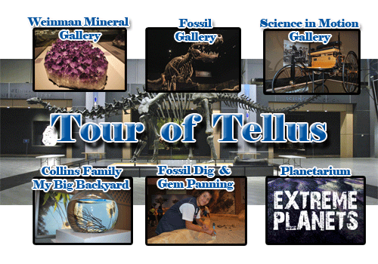

Galleries: Nikon Small World; Earth from Space; The Weinman Mineral Gallery; Fossil Gallery; Science in Motion; Collins Family My Big Backyard; Planetarium; Solar House; Fossil Dig and Gem Panning; Observatory; Cafe; and Store
Admission (Includes Fossil Dig & Gem Panning) Planetarium is extra
Hours of Operation 10:00-5:00
Members – Free Adults - $14 Children (3 - 17) - $10 Student with ID - $10

Tellus Science Museum | I-75 Exit 293, 100 Tellus Drive Cartersville, Georgia 30102 |  | 770-606-5700

