Join Mrs. MacGregor for…An Afternoon at the
The Georgia Mineral Society's
Gem, Mineral, Jewelry, and Fossil Show
Mrs. MacGregor will be there on Saturday, May 13th from 2-4

Parents: This program is totally voluntary! It is not required!! No credit is being given!!!
I realize that this may not fit into your schedule. It is okay!!!!
This is just a suggested activity for you and your family.
All the information you need is listed below
I hope to see you there.
Cobb County Civic Center
548 S. Marietta Parkway, Marietta, GA 30339
------------------------------------------------------------------
The show lasts all weekend
May 12, 13, 14
Show Hours:
Friday: 10 AM to 6 PM
Saturday: 10 AM to 6 PM
Sunday: Noon to 5 PM

FREE Admission!
FREE Parking!
Over 30 Dealers!
Door Prizes!
SPECIAL Door Prizes for Students!
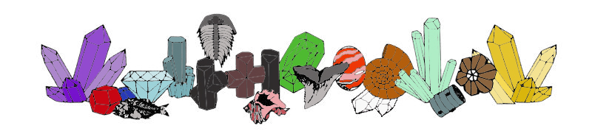
http://www.gamineral.org/showmain.html

